Computer Organization Lab 5 Write up

In my project I had 6 main modules, that included other submodules as well. My top module was called the Top_module. This had my nbit_alu, the Register the nbit_alu outputs to, Verification for the n_bit, and the register that takes in the verification output. The nbit_alu parameterized the onebit_alu W amount of times. The verification module compared the values in the registers to make sure it was correct. In the Onebit_alu, it contained the mov, not, add, sub, or, and the AND modules. It also called the mux which was able to select which of the outputs to use. I also had an add_mux which would give an output of c_out from the adder/subtractor, only if the adder was called.

The Hierarchy I had for the ALU was Top_module, ALU_nbit, alu_onebit, the muxes, and the adder, subtractor, mov, AND, and or modules.

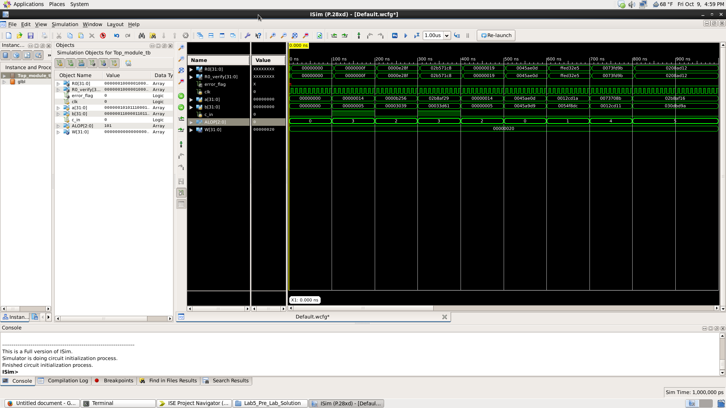

This waveform contains the test cases for all the ALOP codes from 0-5. These cases had values ranging from 20 and 5 to values such as 45657897 and 212321.

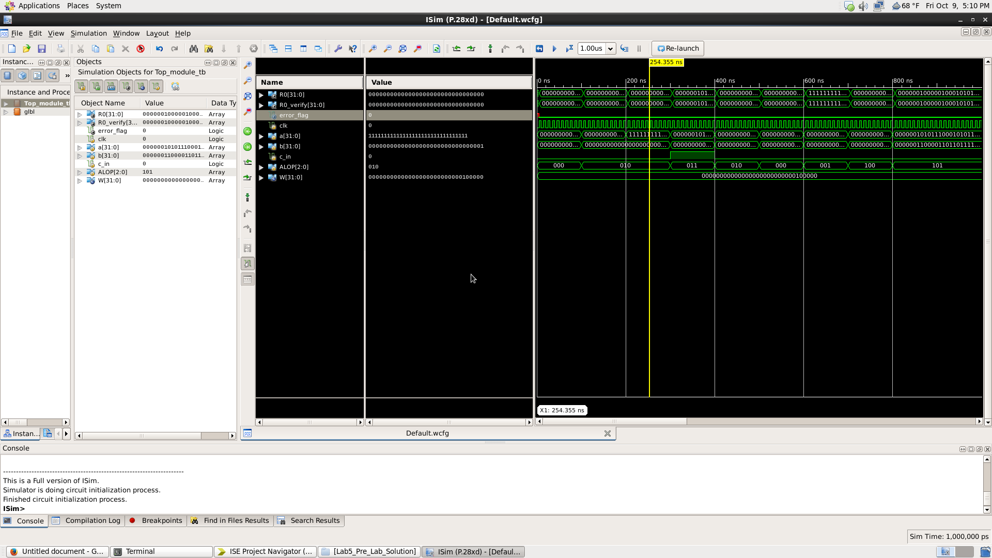

This waveform shows the case where 32’hffff_ffff was added to 1. As you can see the result is correct, which is verified by the error flag, which is 0.

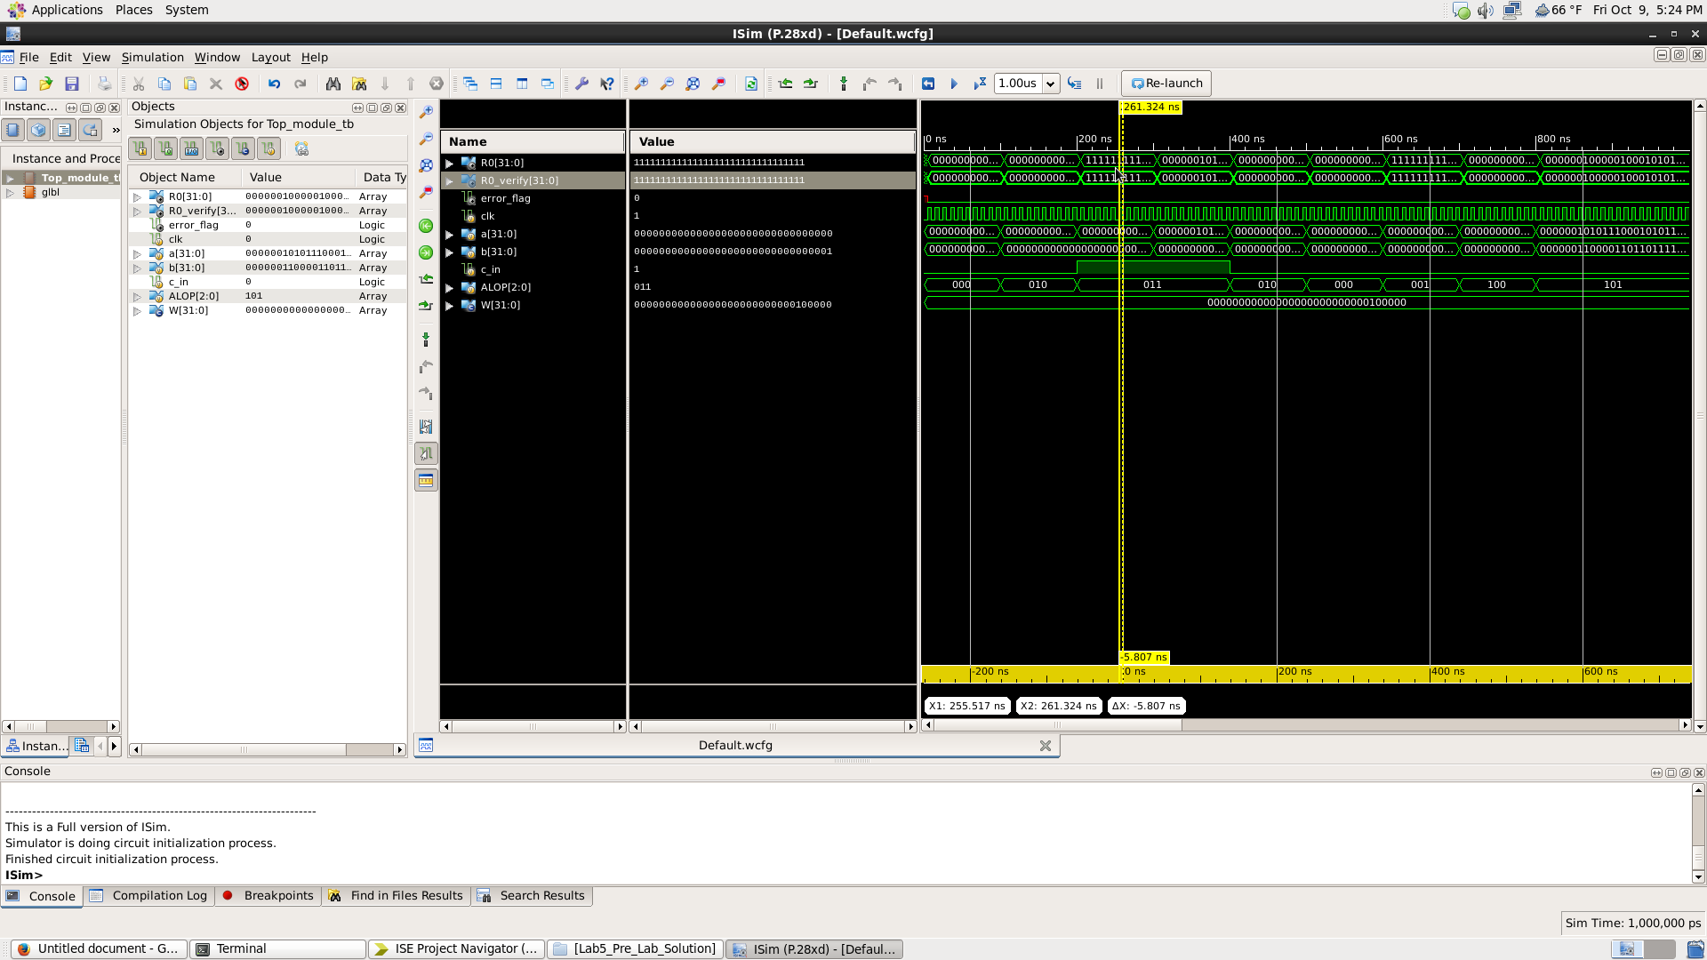

This waveform shows what happens when you do 0 - 1. As you can see from the picture it becomes 32’hffff_ffff.